# Task 1

**What is Kotlin?**

It is a programming language which is free, open source and statically typed “pragmatic” programming language. This was initially designed for the Java Virtual Machine and Android application. With the two mentioned we combine object oriented with functional programming. Kotlin is mainly focused on interoperability, safety and tool support. Kotlin originated from Jet Brains which is the company behind the IntelliJ Idea (Heller. M,2020). Kotlin can be used for any kinds of development for example this can be used for server side, client side and android (JetBrains. (n.d.)). As already mentioned before Kotlin is a typed programming language which makes you get errors at compile time. In Kotlin the developer will write 40% less code when compared to java (Vaidya. N,2019).

The main difference between java and Kotlin are the following. In java when we have a variable and it Is being assigned null, it will return a null pointer exception. While in Kotlin by default the variables are non-nullable. If the user tries to assign a nullable value, the code will fail at compile time. In java, if we need to extend a functionality of existing class, we need to create another class and we inherit the parent class. The current class cannot be extended. Kotlin provides the developers to extend existing class with the new functionality required (Kotlin, 2020). Kotlin exists also for other projects other than android. However this is more common when it comes to android projects.

**Design**

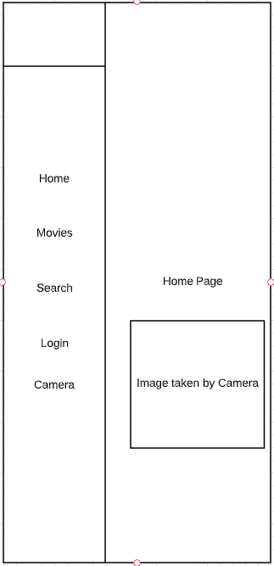

In the above screenshot one has the home page, were the user can access the Camera, search option, login screen and browse through the current popular movies. The user will also be able to view the picture which was taken by himself when accessing the camera.

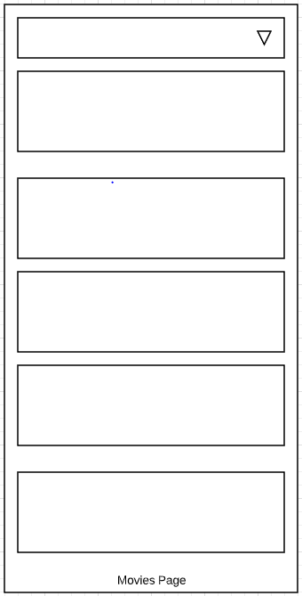

The above screenshot is the movies page, this will have a scroll bar with the list of movie names which are currently popular right now. When the user selects a movie the user will see some details about it. For example the user will select the movie Mulan, and will see a small description about the movie, popularity and if the movie is good for children or adults.

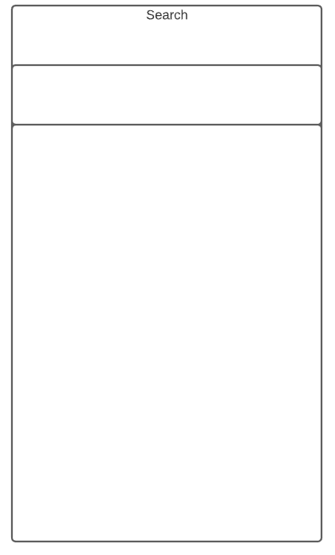

The user will be able to search through the list of movies to see if the current movie exists.

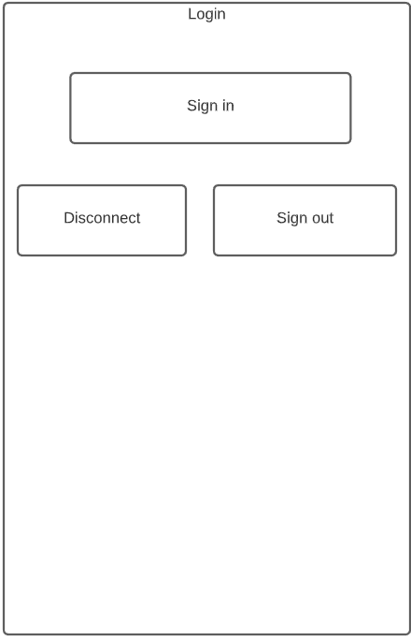

The user will click on the login button and will be prompted to login with google and after the successful login, the user will see 2 more buttons, one which disconnects all the accounts and the other will logout the user from the account.

**Camera**

When the user clicks on the camera menu item, the camera will open and will be able to take photos and these will be displayed on the main page of the application.

**References**

Heller, M. (2020, March 23). What is Kotlin? The Java alternative explained. Retrieved September 21, 2020, from <https://www.infoworld.com/article/3224868/what-is-kotlin-the-java-alternative-explained.html>

JetBrains. (n.d.). FAQ. Retrieved September 21, 2020, from https://kotlinlang.org/docs/reference/faq.html

Vaidya, N. (2019, July 30). What is Kotlin? - A Beginners Guide to Kotlin Programming. Retrieved September 21, 2020, from <https://www.edureka.co/blog/what-is-kotlin/>

Kotlin, J., 2020. *Java Vs Kotlin | 8 Most Amazing Differences You Should Know*. [online] EDUCBA. Available at: <https://www.educba.com/java-vs-kotlin/> [Accessed 6 October 2020].